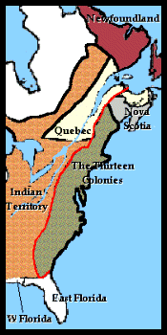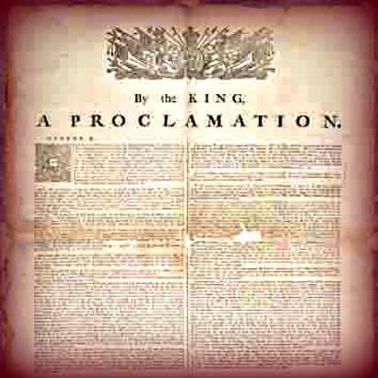Proclamation of 1763

Questions:

1. What effect did this document have on Georgia’s boundaries?

2. Who issued the P. of 1763?

3. What was the purpose of the P. of 1763?

4. What did the Proclamation forbid the colonist from doing?

Scan the QR Code to find out more about the Proclamation of 1763.